📘 One-to-Many Association — Definition
One-to-Many Association is a HAS-A relationship between two classes in which one object of a class is associated with multiple objects of another class.
In this relationship:
- One class holds references to many objects of another class
- The relationship is usually maintained using a collection (List, Set, etc.)
- Both objects can have independent lifecycles
- The relationship is not inheritance (IS-A)

🔗 Establishing One-to-Many Association
A one-to-many association can be created in two ways:

1️⃣ Constructor Injection
The collection of dependent objects is passed through the constructor at the time of object creation.
👉 Ensures the association is set when the object is created.
Example idea (concept):
A Department is created with a list of Employees.
Eg: Employee_02, Department, One_Many_Association_Using_Constructor
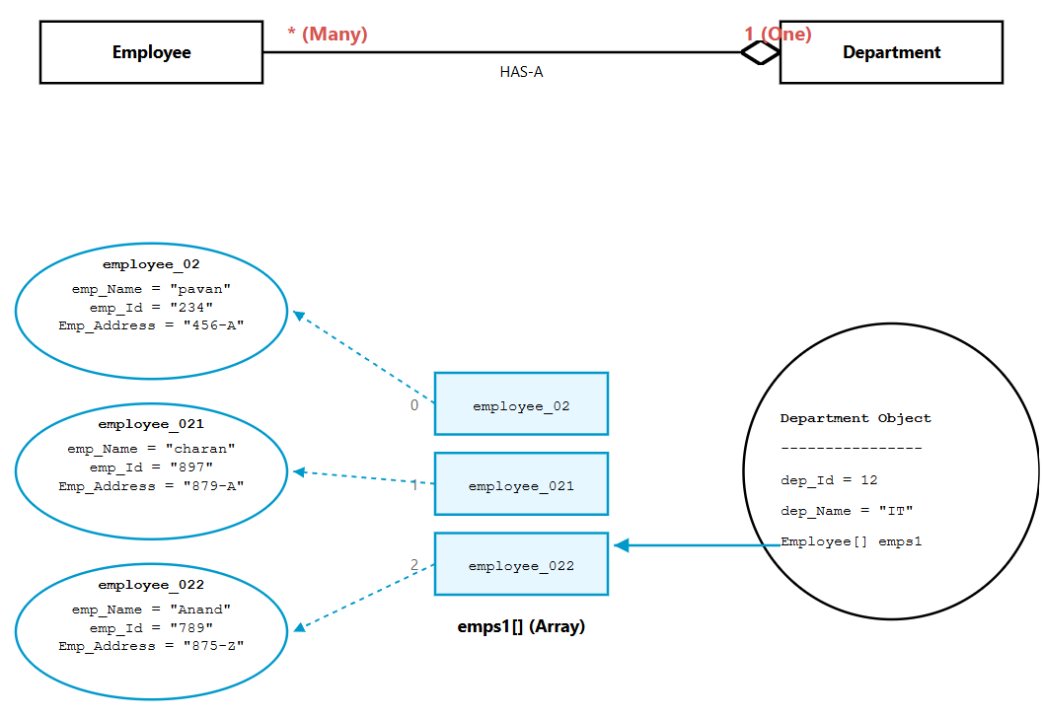

2️⃣ Setter Injection
The collection of dependent objects is set later using a setter method, after the object is created.
👉 Allows the association to be added, removed, or modified at runtime.
Example idea (concept):
A Department is created first, Employees are added later.
Eg: One-Many_Association_Using_Setter_Getter , Employee_03 , Department_1

📘 Many-to-One Association — Definition
Many-to-One Association is a HAS-A relationship between two classes in which multiple objects of one class are associated with a single object of another class.
In this relationship:
- Many objects hold a reference to one common object
- The reference is usually stored as a single object variable (not a collection)
- Both objects can have independent lifecycles
- The relationship is not inheritance (IS-A)

🔑 Core Clarification
When I said:
“In many-to-one, collection should not be used”
I meant:
👉 Inside the class that represents the MANY side
NOT in main().

🧠 Where should collection NOT be used?
In many-to-one, the MANY side class must look like this:
class Student {
Branch branch; // single reference
}
❌ It should NOT be:
class Student {
List<Branch> branches; // WRONG for many-to-one
}
Because that would become:
👉 Many-to-Many

🔍 What did we do in your code?
Inside Student_02:
private Branch_01 branch_01;
✔ Single reference
✔ Correct for many-to-one

🤔 Then what about this in main?
Student_02[] students = { student_03, student_04, student_05 };
This array is just:
👉 For looping and printing
👉 For grouping objects
👉 Not part of association modeling
It does NOT define relationship type.

🚨 VERY IMPORTANT RULE
Association type is decided by class design (fields)
NOT by arrays or lists created in main().

🎯 Real difference
This defines many-to-one:
class Student {
Branch branch; // SINGLE reference
}
This defines one-to-many:
class Branch {
List<Student> students; // COLLECTION reference
}

📌 So your doubt resolved:
Using:
Student_02[] students
in main()
✔ DOES NOT change association
✔ DOES NOT violate many-to-one
✔ Is only for iteration

🧠 Final Lock Statement
Collections inside a model class define association type.
Collections inside main() are just for convenience and do not affect association direction.

🔗 Establishing Many-to-One Association
A many-to-one association can be created in two ways:

1️⃣ Constructor Injection
The common object is passed through the constructor at the time of object creation.
👉 Ensures the association is set when the object is created.
Example idea (concept):
Multiple Employees are created with the same Department.

Eg: Many_One_Using_Constructor, Branch_01, Student_02

2️⃣ Setter Injection
The common object is set later using a setter method, after the object is created.
👉 Allows the association to be assigned or changed at runtime.
Example idea (concept):
Employees are created first, the Department is assigned later.

Eg: Many_One_Using_Setters_Getters, Branch, Student_01

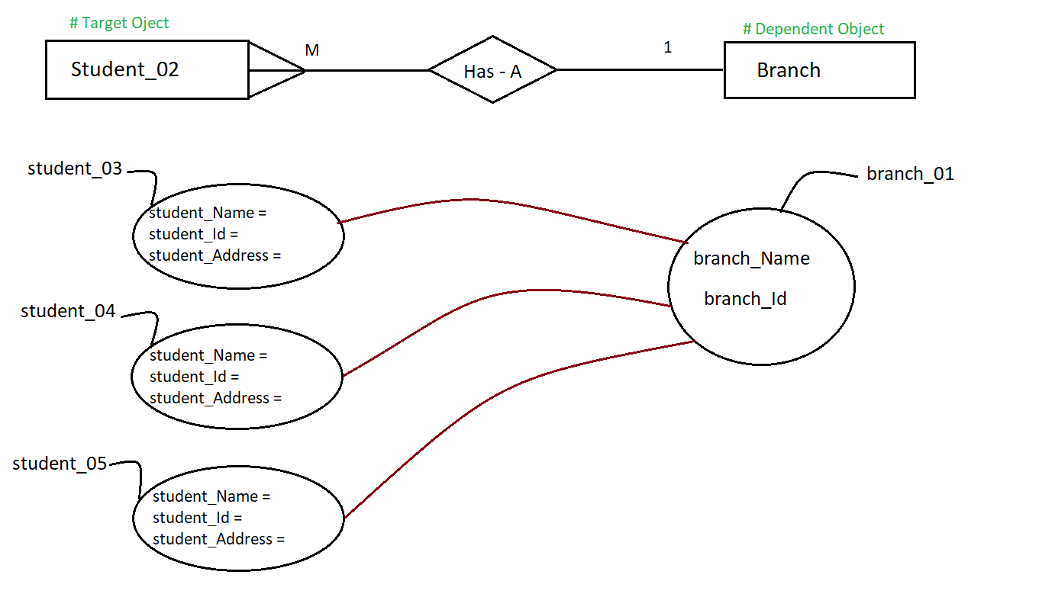

📘 Many-to-Many Association — Definition
Many-to-Many Association is a HAS-A relationship between two classes in which multiple objects of one class are associated with multiple objects of another class.
In this relationship:
- Many objects hold references to many objects
- Both classes usually maintain a collection reference
- The relationship is typically maintained using a collection (List, Set, etc.) on both sides
- Both objects have independent lifecycles
- The relationship is not inheritance (IS-A)

🔗 Establishing Many-to-Many Association
A many-to-many association can be created in two ways:

1️⃣ Constructor Injection
The collection of associated objects is passed through the constructor at the time of object creation.
👉 Ensures the association is established during object creation.
Example idea (concept):
A Student is created with a list of Courses.
A Course is created with a list of Students.

Eg: Many_Many_Using_Constructor , Course , Student_03

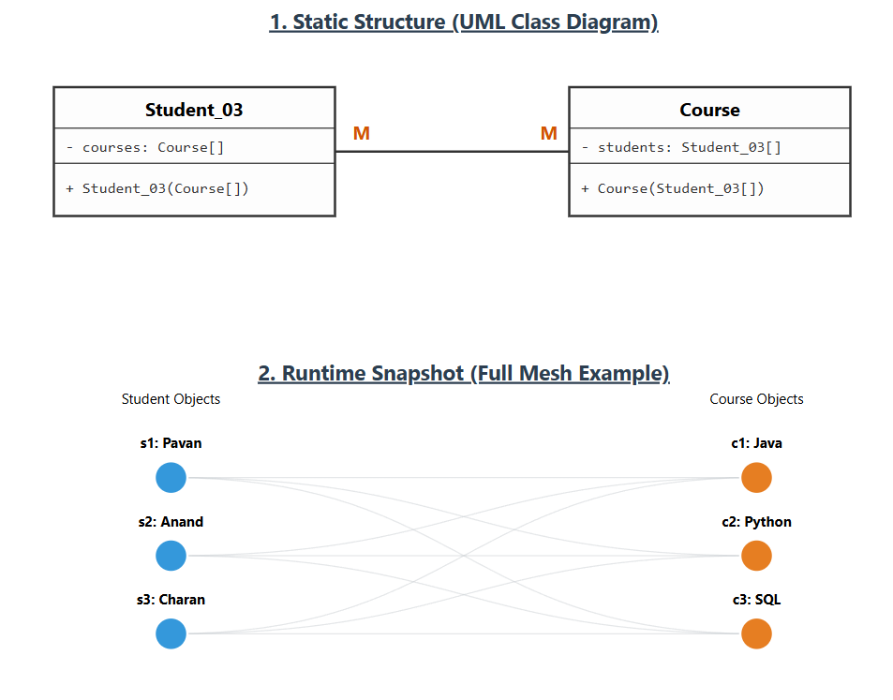

2️⃣ Setter Injection
The collection of associated objects is set later using setter methods after object creation.
👉 Allows the association to be added, removed, or modified at runtime.
Example idea (concept):
A Student is created first.
Courses are assigned later using a setter or add method.
Similarly, a Course may add or remove Students later.
Eg: Many_Many_Using_Setter_Getter , Course_01 , Student_04

Eg: Has-A-Relation_Eg1
🧠 What Is Actually Happening (Memory Understanding)
Step by step:
1️⃣ Inner i = new Inner();
→ One Inner object created in heap.
2️⃣ i.setX(10);
→ x = 10 inside that object.
3️⃣ o.setY(i);
→ Outer now stores reference to SAME Inner object.
Memory looks like:
o --------> Inner object (x = 10)
i --------> same Inner object
4️⃣ i.setX(100);
→ You are modifying SAME object.
So now:
Inner object (x = 100)
5️⃣ System.out.println(o.getY().getX());
Since o.y points to same object, it prints:
100

Let me rewrite the code clearly first:
public class Hello {

String title;
int value;

public Hello() {
title += " World";
}

public Hello(int value) {
this.value = value;
title = "Hello";
Hello(); // ❌ compile error
}
}
And in main:
Hello c = new Hello(5);
System.out.println(c.title);

🔴 The Main Problem
This line:
Hello();
inside constructor is illegal in Java.
👉 Constructors CANNOT be called like normal methods.
That is why compiler gives:
CE (Compile Error)

🧠 Why Is It Compile Error?
In Java:
- Constructors are NOT normal methods.
- They can only be called using:
  - new
  - or this()
  - or super()
You cannot directly call:
Hello();
Because that looks like a method call.
But constructor is NOT a method.

✅ Correct Way to Call Another Constructor
If you want to call default constructor from parameterized constructor:
You must use:
this();
AND it must be the first statement.
Correct version:
public Hello(int value) {
this(); // must be first line
this.value = value;
title = "Hello";
}

